1. Sign In to Paypal Devloper Account
2. Create One App
3. Copy Client_id And Secret_id

1) To Generate token

Set the verb to POST.
Enter https://api-m.sandbox.paypal.com/v1/oauth2/token as the request URL.
Select the Authorization tab.
From the TYPE list, select Basic Auth.
In the Username field, enter your client ID.
In the Password field, enter your secret.
Select the Body tab.
Select the x-www-form-urlencoded option.
In the KEY field, enter grant_type.
In the VALUE field, enter client_credentials.
Select Send.

Request Type = Post
Request Url = https://api-m.sandbox.paypal.com/v1/oauth2/token

2) Checkout Order
Request Type =Post
Request Url = https://api-m.sandbox.paypal.com/v2/checkout/orders

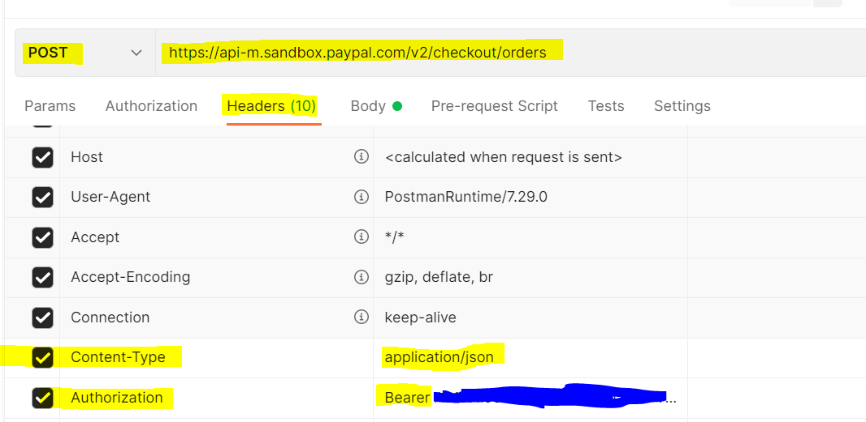
Token Value

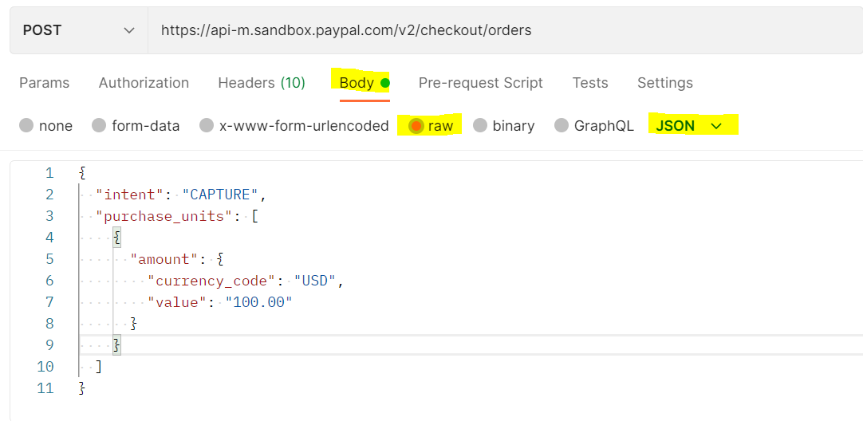

Paylode =
{
"intent": "CAPTURE",
"purchase_units": [
{
"amount": {
"currency_code": "USD",
"value": "100.00"
}
}
]
}

